SAFE@WORK

HAZARD IDENTIFICATION SIGN ORDER FORM
This form is to be attached to a ‘Print Requisition Form’ and forwarded directly to Print & Distribution Services.
If you have any questions about the completion of this order form or the signs themselves, please contact the WHS unit on extension 3931 or whs-admin@uow.edu.au.
SECTION 1: Ordering Details
Requisition No: |  |  |  |  | Date: / /
Contact Name: |  |  |  |  | Extension:
Email:
(The Printery will send an electronic copy of the sign requested to the contact email address above for final checking)
Number of Laminated A3 Signs Required ($8 each):
SECTION 2: Location Details
Name of Location (eg 41.G53 Radiation Waste Store):
Faculty/Division: |  |  |  |  | School/Unit:
Supervisor Name: |  |  |  |  | Contact Number:
After Hours Contact Name: |  |  |  |  | Contact Number (optional):
Campus: | Batemans Bay  Loftus |  | Bega  Moss Vale |  |  | Innovation Campus  Shoalhaven |  | Liverpool  Wollongong
SECTION 3: Hazards in the Area
Dangerous Goods
1 Explosive  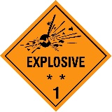 |  | 2.1 Flammable gas  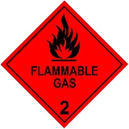 |  | 2.2 Non-flammable,  non-toxic gas  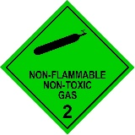 |  |  | 2.3 Toxic gas  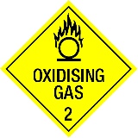 |  | 3 Flammable liquid  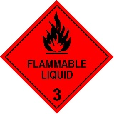
4.1 Flammable solid  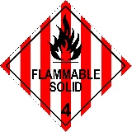 |  | 4.2 Spontaneously combustible  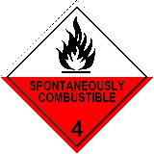 |  | 4.3 Dangerous when wet  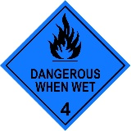 |  |  | 5.1 Oxidising substances  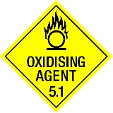 |  | 5.2 Organic peroxides  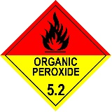
6.1 Toxic substances  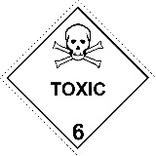 |  | 6.2 Infectious substances  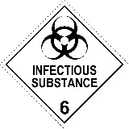 |  | 7 Radioactive material  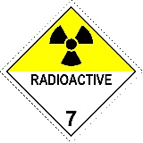 |  |  | 8 Corrosive substances  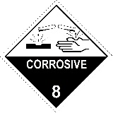 |  | 9 Miscellaneous  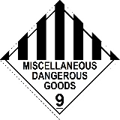

Physical Hazards
Confined space | Extreme cold  Extreme heat  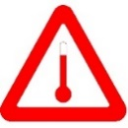 | High noise area | Ionising radiation | Non-ionising radiation
UV  d | Other:
Plant & Equipment Hazards
Crush | Electrical | Forklift in use | High voltage | Hydraulic pressure
Laser  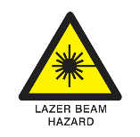 | Magnetic field | Welding | Other:
Other Hazards
Asphyxiation  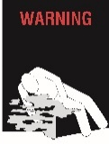 | Biological  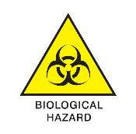 | Cryogenics | Cytotoxic | Heights
High oxygen | Other:
SECTION 4: Precautionary Measures Required
Eye protection must be worn  Goggles  When necessary | Eye and hearing protection must be worn  When necessary | Face protection must be worn  Welding mask  When necessary | Foot protection must be worn  Enclosed  Impervious  Steel capped  When necessary | Hand protection must be worn  When necessary
Head protection must be worn  When necessary | Hearing protection must be worn  When necessary | Long hair must be contained or covered  When necessary | Protective body clothing must be worn  When necessary | Respiratory protection must be worn  Half face mask  Full face mask  When necessary

Keep walkways clear | Ventilated area required for storage | Strictly no admittance without supervision | Fire, naked flame and smoking prohibited | Water not suitable for drinking
No pedestrian access | Smoking prohibited | No eating or drinking | Do not wear thongs | Other:
SECTION 5: Facilities
Fire equipment | Chemical spill kit | Biohazard spill kit | Mercury spill kit | Cytotoxic spill kit
First aid kit | Safety shower | Eyewash station | Safety shower & eyewash station | Emergency power shut down available  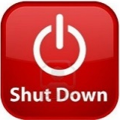
Other:

